THROWABLE PROGRAM

1) import java.util.Scanner;

public class Main

{

public static void main(String[] args) {

try{

int x=10;

int y=0;

int z=x/y;

System.out.println(z);

}

catch(Throwable err){

System.out.println(err.getMessage());

}

}

}

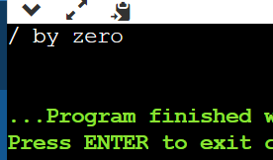

2) import java.util.Scanner;

public class Main

{

public static void main(String[] args) {

try{

int x=10/0;

}

catch(ArithmeticException err)//Execution err {

{

System.out.println("ArithmeticException="+err.getMessage());

}

finally{

System.out.println("This is the final block");

}

}

}

